Automatic communication logging
User Story: As a realtor, I want visually clear timeline in the client/lead profile that shows all communication activities (like calls, emails, and messages) sorted by type and date, so that, I can easily review the interaction history.
Assuming backend implementations are complete, customization to be done in the Salesforce org are given here.
When the user navigates to a lead record page on the Salesforce, user should land on a page which displays all kinds of communications (SMS, Email, Phone calls).
- All communication should be displayed in chronological order by default and UI should be a timeline view like in the below given screenshot.
- Also, user should be able to filter the communication by type of the communication and date range with the controls available in the UI.
- User should be able to sort the communications by communication type and date, default should be most recent on the top.
- Most recent conversations should be of unique format (Bold font)
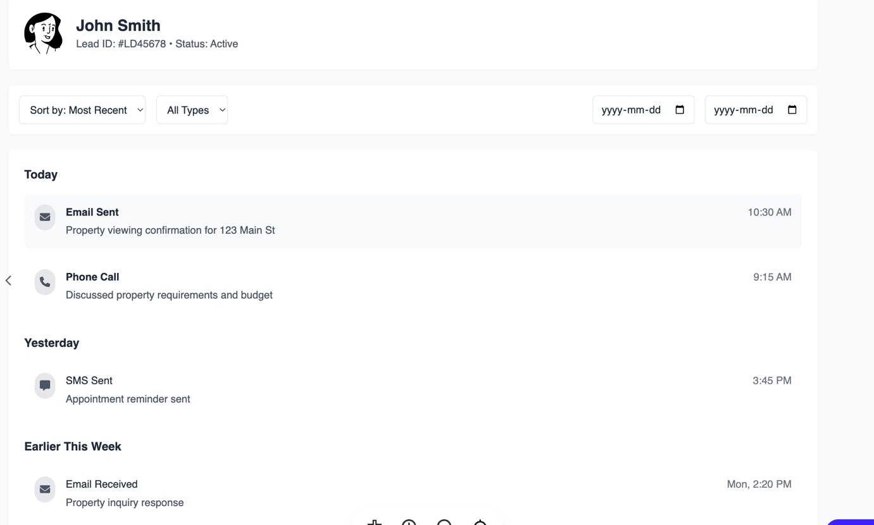
4. Recent conversations highlighted with bold font.
3. Sort
2. Filter
1.Chronological order

Sections of the UI indicating specific features are highlighted and pointed pictorially with arrows, corresponding feature name and number.

